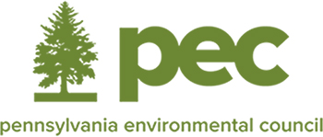

Philadelphia Environmental Partnership Dinner November 17, 2022
Sponsorship Commitment Form

Yes, ________________________________________________________will contribute $__________
(Name of company as it should appear in recognition)

____Title Dinner Sponsor: $10,000
____Welcome Reception Sponsor: $5,000
____Wine Sponsor: $3,500
____Curtin Winsor Award Sponsor $2,500
____Responsible Printing Sponsor: $2,000
____Carbon Neutral Sponsor: $2,000
____ Silent Auction Sponsor: $2,000

To confirm availability of the above sponsorship opportunities or for additional information please contact Jennifer Torman at jtorman@pecpa.org or 215-545-4570 ext. 100.

____Premier Benefactor: $5,000
____Benefactor: $3,000
____Contributor: $1,500
____I’m unable to attend, enclosed please find my contribution in the amount of $__________

Contact Information:

Name:

Title:

Address:

City State Zip

Phone Email

Payment: ___ Check Enclosed ___Please send invoice for amount indicated above.
Mail form and check to: PEC 1315 Walnut Street Suite 532 Philadelphia, PA 19107

A copy of the official solicitation registration and financial information may be obtained from the Pennsylvania Department of State by calling toll free, within Pennsylvania, 800-732-0999. Registration does not imply endorsement.

